

Updating the list of electricity generators with CPO powers in the CBL
Documentation and checklist

November 2024

Author/updater | Jo Gerulaitis
Date | 23/09/2025
Version | 0.3

Tasks for person with Python installed (EST updater or Jo Gerulaitis):

Download the new Ofgem list (PDF) and extract users
Task description
Download the latest Ofgem list (PDF) file available at List of all electricity licensees including suppliers | Ofgem) and save to directory Python scripts are stored in in the format electricity_licencees_YYYYMMDD.pdf where the date is the date in the PDF, not the date of download.
Open extractOfgemLicenceesPDF.py in an IDE. Update the ofgem_pdf_filename variable to reflect the file name of the PDF saved above.

Run the file. You should now see a comma separated value file of the form “electricity_licencees_YYYYMMDD.csv”

Open the csv and check that column A contains “ELECTRICITY GENERATION” for all rows, column B contains the name of the company and column C has a company number for all rows and that there are no other columns/rows.

Check that the name/number of the first and last generator in the PDF list are the first and last in the csv.

Send CSV to home computer to run the Companies House API script, as PINS blocking at moment.
Send result back to PINS email and then reformat to be like previous “ofgem_list_summary_YYYYMMDD.xlsx”, investigating any that were not found / don’t match previous address information.

Tasks for EST updater:

Request updated Ofgem List Summary dataset
Task description
Email / Teams message Jo Gerulaitis to get Ofgem List Summary. This will be provided in the form “ofgem_list_summary_YYYYMMDD.xlsx”. Jo will also provide the PDF that this file is based on. Save these to an appropriate SharePoint folder.
Check that the date is as you expect (i.e. that it matches the date in the top of the PDF file available at List of all electricity licensees including suppliers | Ofgem)

Update the Consultation Body List (CBL)
 | Task description
2.3 | Open the master copy (template) of the “CBL” (Master Copy – Consultation List – Reg 8 Notification of Scoping Request.xlsx).
2.4 | Navigate to the “Generators” tab. On the top ribbon, click “Review”, then “Unprotect Sheet”. Enter the password “generators_update” when prompted (with the underscore but without the quote marks). Remove all filters/ensure they are not filtering (Data > Filter).
2.5 | Navigate to the “Generators_Update” tab. On the top ribbon, click “Review”, then “Unprotect Sheet”. Enter the password “generators_update” when prompted (with the underscore but without the quote marks). Remove all filters/ensure they are not filtering (Data > Filter).
2.6 | Delete the values from columns A to H, leaving just the headings in place. Ensure all rows (apart from the header row) for columns A to H are deleted. Do not delete columns I or J.
2.7 | Copy and paste (as values) the values from your “ofgem_list_summary_YYYYMMDD.xlsx” (without the header row) file into columns A to H that you’ve just emptied. Click away so you are not selecting any cells.
2.8 | Add filters to all columns by clicking on the “Data” tab in the top ribbon, followed by the “Filter” icon.  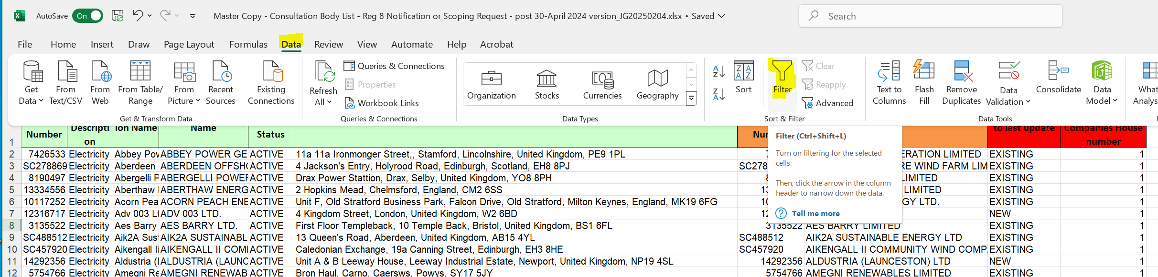
2.9 | Filter column I “Status relative to last update” to “NEW” and column J “Ofgem licence number matches Companies House number” to 0.
2.10 | For each row:  Compare the “Ofgem Register Name” (column D) with the “Companies House Name” (column H). Do they appear to be the same company? If you’re not sure, do some investigation on Companies House (https://find-and-update.company-information.service.gov.uk/) to see if you can find a better match.  You could try searching for the Ofgem Register Name or Ofgem Licence Number. Update the “Address Block”, “Companies House Name”, “Companies House Number” columns (columns F, G, H) if you find something more appropriate.
2.11 | Clear the filter on column J, but leave the filter on column I so that you now have all “NEW” companies.
2.12 | Copy the values from columns A to D for all “NEW” rows and paste (as values) these at the bottom of the list on the “Generators” tab (the first blank row) in columns A to D. Do the same for column F (“Address Block”) pasting into column H on the “Generators” tab.
2.13 | Copy down the formula in column E of the “Generators” tab to all rows you’ve just added.
2.14 | Copy down the formula in column F of the “Generators” tab to all rows you’ve just added.
2.15 | Copy down the formula in column G of the “Generators” tab to all rows you’ve just added, ensuring that all NEW rows are set to “Letter”.
2.16 | Update / add to columns L, M of the “Generators” tab to indicate when the update was done and by whom. Reapply filers (Data > Filter).
2.17 | On the top ribbon, click “Review”, then “Protect Sheet”.  Ensure that the following are ticked: Select locked cells, Select unlocked cells, Sort, Use AutoFilter  Enter the password “generators_update” when prompted (with the underscore but without the quote marks).
2.18 | Navigate back to the Generators_Update tab and remove all filters (Data > Filter). On the top ribbon, click “Review”, then “Protect Sheet”. Enter the password “generators_update” when prompted (with the underscore but without the quote marks).
2.19 | Navigate back to the “Consultation Body List” tab, save the file.
2.20 | Get your update QAd/checked and then upload to SharePoint/request Steph Newman or Emma Cottam upload this as the new template.

